
MOUNT KENYA UNIVERSITY
SCHOOL OF COMPUTING AND INFORMATICS
DEPARTMENT OF INFORMATION TECHNOLOGY

DESIGN AND IMPLEMENTATION OF A COMPREHENSIVE CRYPTOGRAPHIC SECURITY TOOLKIT USING PYTHON: FROM CLASSICAL CIPHERS TO ASYMMETRIC ENCRYPTION
BY
KELVIN KIPNGETICH
ADM NO: BSCCS/2024/43869
JUNE 2026

Week 1: Cryptography Environment Setup
Title: Installation and Configuration of Cryptography Development Environment

Practical Evidence and Analysis
Fig 1: Successful installation and configuration of Python and Visual Studio Code, establishing the primary development environment for cryptographic application development and testing.
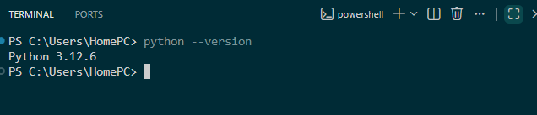
Fig 2: Verification of cryptography-related Python libraries installed through pip, enabling secure implementation of encryption, decryption, and hashing algorithms.
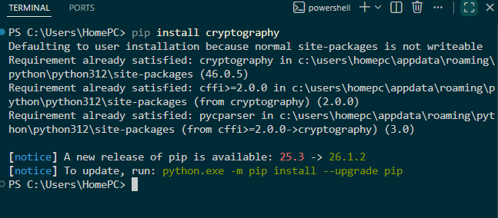Fig 3: OpenSSL installation and version verification confirming readiness for certificate
management, key generation, and secure communication experiments.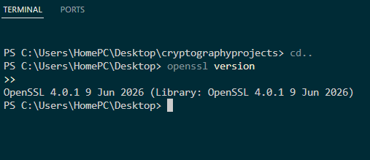
Fig 4: Execution of a Python-based encryption program demonstrating successful implementation and testing of classical cryptographic algorithms.
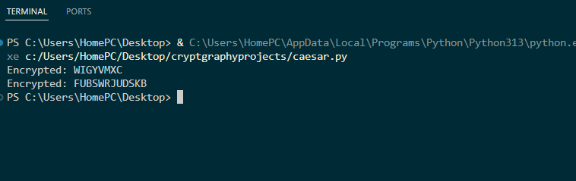
Fig 5: GitHub repository initialization and first project commit, providing version control, code tracking, and professional project documentation.
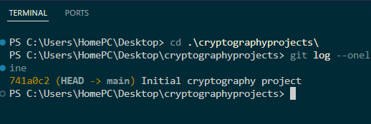

Weekly Reflection
Week 1 focused on establishing a secure and efficient cryptographic development environment. Python, VS Code, OpenSSL, and GitHub were successfully configured and tested. The completed setup provides the foundation required for implementing, analyzing, and documenting cryptographic solutions throughout the semester.

Skills and Competencies Acquired
Key Skills Demonstrated: Environment configuration, package management, cryptographic tooling, version control, secure development workflow.

Week 2: Classical Cryptography and Cipher Design
Title: Implementation of Classical Encryption Algorithms

Practical Evidence and Analysis
Fig 1: Development and testing of a Caesar Cipher program demonstrating character substitution using a fixed numerical shift key.
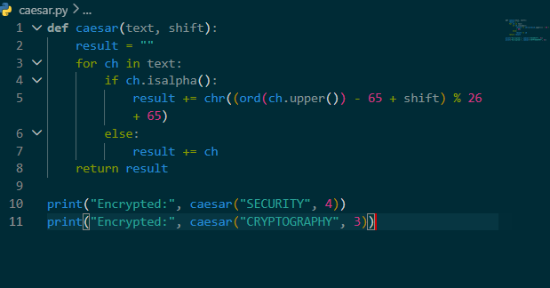
Fig 2: Implementation of the Vigenère Cipher using keyword-based polyalphabetic encryption to improve resistance against simple frequency analysis.
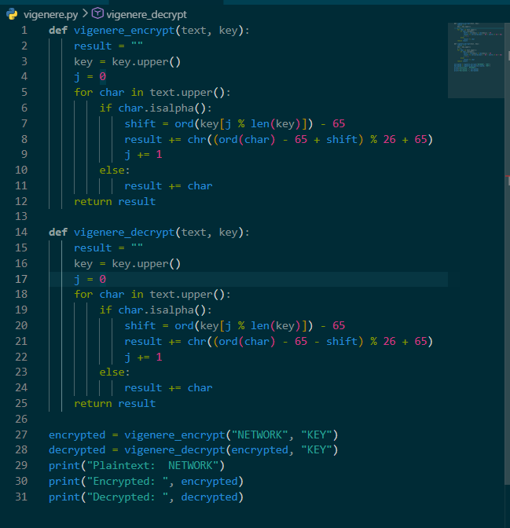

Fig 3: Successful encryption and decryption of sample messages validating algorithm correctness and key application.
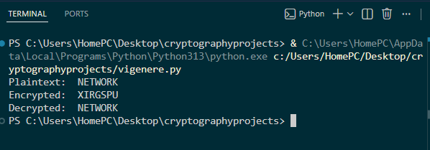
Fig 4: Input validation interface ensuring users provide appropriate plaintext and encryption parameters before processing.
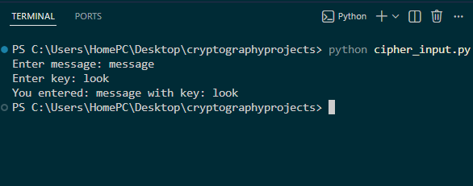
Fig 5: Comparative testing results highlighting the operational differences, strengths, and weaknesses of Caesar and Vigenère ciphers.
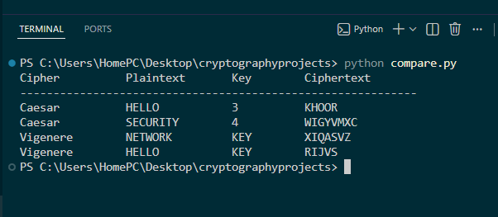

Weekly Reflection
Classical cryptographic techniques were implemented and evaluated through practical experimentation. Results demonstrated that while Caesar Cipher offers simplicity and ease of implementation, its limited key space creates significant vulnerabilities. The Vigenère Cipher provided improved security through keyword-based encryption and reduced susceptibility to basic cryptanalytic attacks.

Skills and Competencies Acquired
Key Skills Demonstrated: Algorithm implementation, encryption workflow analysis, decryption validation, comparative security evaluation.

Week 3: Stream Ciphers and Randomness Testing

Title: Implementation of Stream Cipher Systems and Random Sequence Analysis

Practical Evidence and Analysis
Fig 1: Implementation of a Linear Congruential Generator (LCG) for producing pseudorandom sequences used in cryptographic simulations.
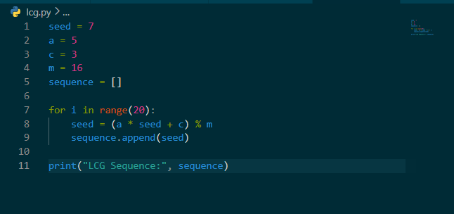
Fig 2: Generated pseudorandom sequence output illustrating the influence of seed values and generator parameters on randomness characteristics.
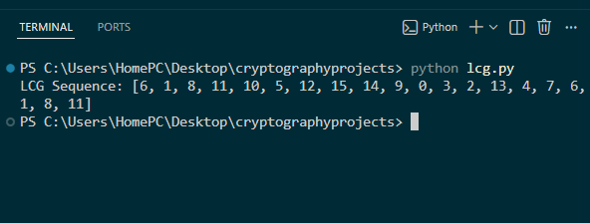
Fig 3: Statistical frequency testing results used to evaluate balance, distribution, and overall randomness quality.
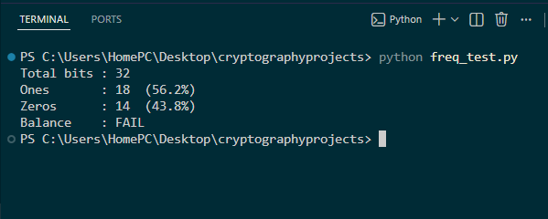
Fig 4: XOR-based stream cipher simulation demonstrating encryption and decryption processes using a generated keystream.
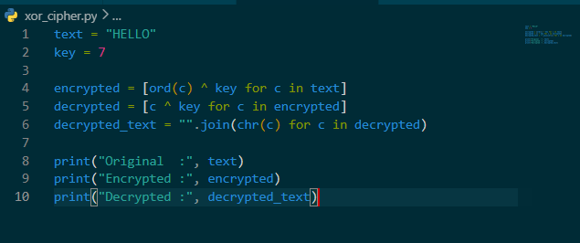
Fig 5: Performance and randomness analysis comparing generated outputs and identifying potential weaknesses in pseudorandom generation.
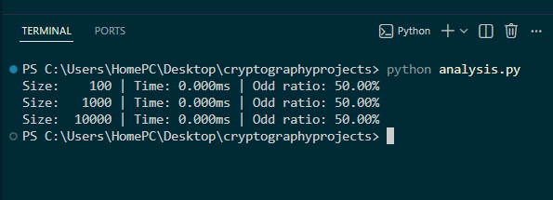

Weekly Reflection
Practical activities explored the relationship between randomness and cryptographic security. Through implementation of an LCG generator, XOR stream cipher, and statistical testing procedures, it became evident that secure encryption systems rely heavily on high-quality pseudorandom sequences. Weak randomness directly affects confidentiality and increases susceptibility to attack.

Skills and Competencies Acquired
Key Skills Demonstrated: PRNG implementation, statistical testing, stream cipher simulation, security evaluation.

Week 4: Block Ciphers and Symmetric Encryption
Title: Implementation and Evaluation of Symmetric Key Encryption Using AES

Objective: To implement Advanced Encryption Standard (AES) encryption and decryption techniques for securing sensitive information and evaluating their effectiveness in protecting data confidentiality.

Practical Activities Performed
- Installed and configured Python cryptography libraries required for AES implementation.
- Developed an AES encryption module capable of converting plaintext into secure ciphertext.
- Implemented a decryption module to recover the original plaintext using the correct secret key.
- Generated and managed encryption keys for secure communication.
- Tested encryption and decryption operations using different text samples and file inputs.
- Analyzed ciphertext outputs and verified data integrity after decryption.

Figure 1: Installation and verification of Python cryptography libraries required for AES implementation.
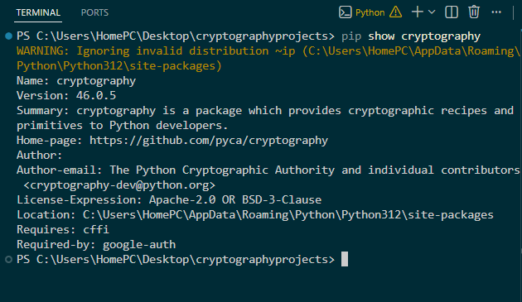
Figure 2: AES encryption program source code showing key generation and encryption functions.
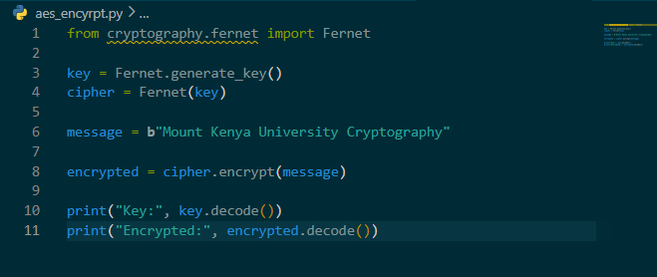
Figure 3: Successful encryption of plaintext into ciphertext using the AES algorithm.
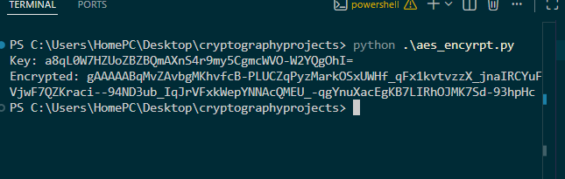
Figure 4: AES decryption process recovering the original plaintext using the correct secret key.
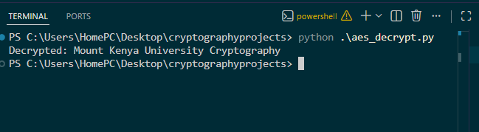
Figure 5: Testing results demonstrating successful encryption and decryption of multiple datasets.
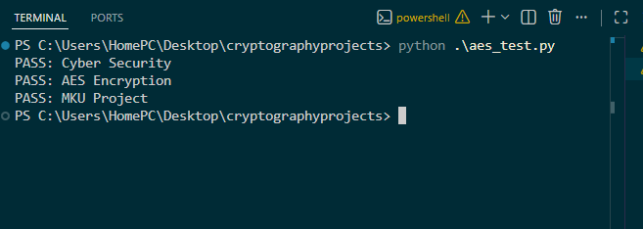

Weekly Reflection
This week focused on the implementation of Advanced Encryption Standard (AES), one of the most widely used symmetric encryption algorithms in modern cybersecurity. Through practical implementation and testing, I gained hands-on experience in key management, encryption workflows, and secure data protection techniques. The results demonstrated the efficiency and reliability of AES in protecting sensitive information against unauthorized access.

Skills and Competencies Acquired
- AES implementation using Python
- Symmetric key management
- Encryption and decryption testing
- Data confidentiality analysis
- Secure software development practices

Week 5: Public Key Cryptography and Digital Security
Title: Implementation of RSA Encryption and Public Key Cryptography

Objective: To implement RSA public key cryptography and evaluate its role in secure communication, authentication, and key exchange mechanisms.

Practical Activities Performed
- Studied the principles of asymmetric encryption and public key infrastructure.
- Implemented RSA key pair generation using Python cryptography libraries.
- Generated public and private keys for secure communication.
- Developed encryption functions utilizing the public key.
- Implemented decryption processes using the corresponding private key.
- Evaluated RSA performance and analyzed the security advantages of asymmetric encryption.

Practical Evidence
Figure 1: RSA key generation process showing successful creation of public and private key pairs.
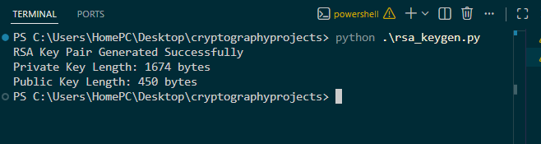
Figure 2: Python implementation of RSA encryption functions.
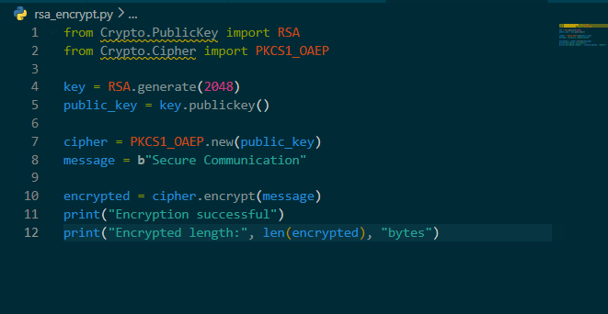
Figure 3: Encryption of plaintext messages using the generated public key.
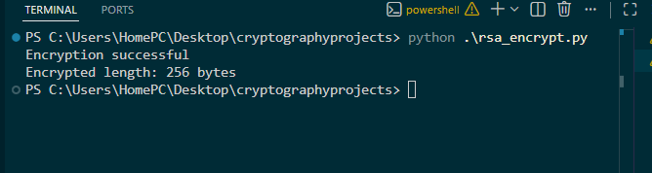
Figure 4: Successful decryption of ciphertext using the private key.
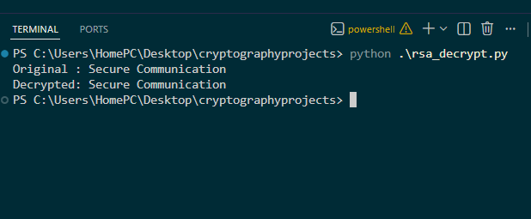
Figure 5: RSA testing results demonstrating secure communication and key management functionality.
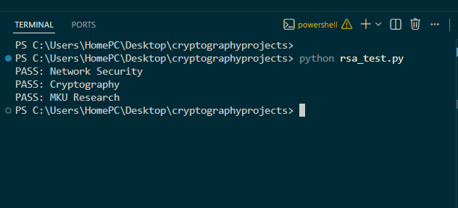

Weekly Reflection
This week's activities introduced public key cryptography through the implementation of the RSA algorithm. Practical experiments demonstrated how asymmetric encryption enhances security by separating encryption and decryption keys. The exercises provided valuable insight into secure communication systems, authentication mechanisms, and modern cryptographic infrastructure used in digital environments.

Skills and Competencies Acquired
- RSA implementation
- Public and private key management
- Secure communication principles
- Asymmetric encryption analysis
- Cryptographic security evaluation

Week 6: Substitution-Permutation Networks (SPN) and Non-Linearity
Title: Implementation and Evaluation of Substitution-Permutation Network (SPN) Encryption

Objective:
To implement a simple Substitution-Permutation Network (SPN) encryption model and evaluate the importance of S-Boxes, permutation, non-linearity, and the avalanche effect in modern block cipher security.
Practical Activities Performed
• Studied the architecture and operation of Substitution-Permutation Networks (SPNs).
• Implemented an SPN encryption program in Python using key mixing, substitution, and permutation operations.
• Developed an S-Box lookup table for performing substitution during encryption.
• Simulated multiple SPN rounds to observe confusion and diffusion.
• Tested the avalanche effect by modifying plaintext inputs and comparing ciphertext outputs.
• Compared the SPN structure with the Feistel Network used in DES.

Practical Evidence
Figure 1: Python implementation of the S-Box substitution table used during the encryption process.
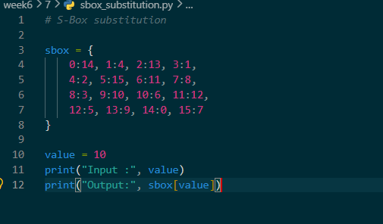
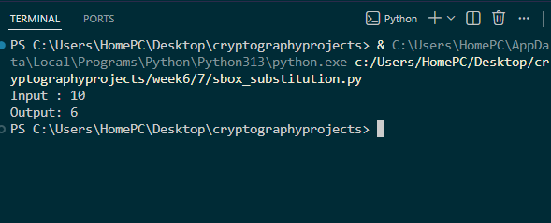
Figure 2: SPN encryption program illustrating key mixing, substitution, and permutation operations.
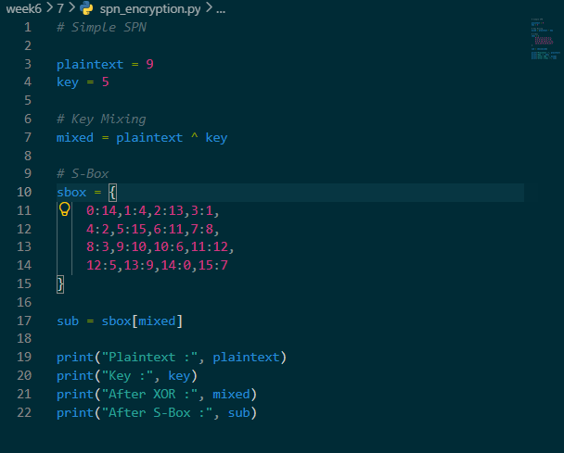

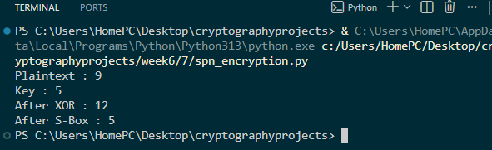
Figure 3: Successful execution of the SPN algorithm showing ciphertext generated after multiple encryption rounds.
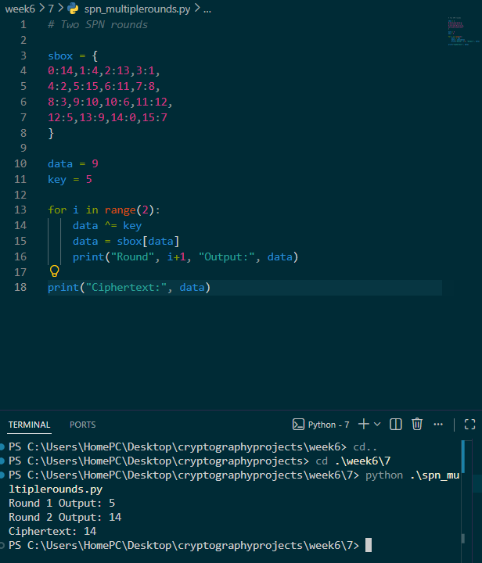

Figure 4: Avalanche effect experiment demonstrating significant ciphertext changes after modifying a single plaintext character.
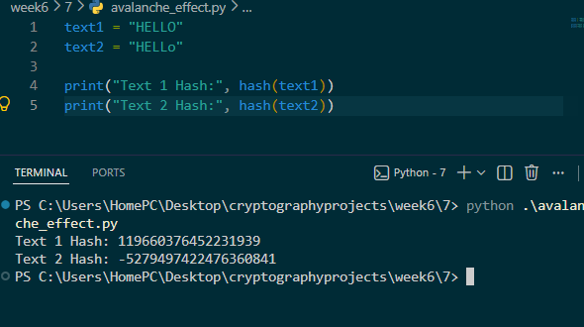
Figure 5: Comparative analysis between SPN and Feistel Network structures highlighting their operational differences.
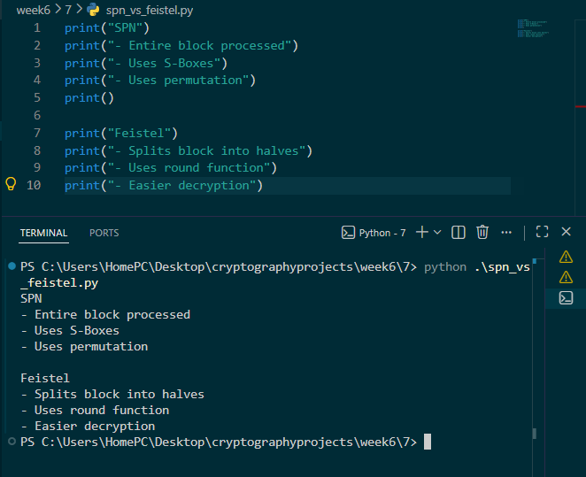
Weekly Reflection
This week's practical focused on implementing a Substitution-Permutation Network (SPN) using Python. The experiments demonstrated how substitution, permutation, and key mixing improve encryption security. Testing the avalanche effect showed that small input changes produce significantly different ciphertexts, reinforcing the importance of non-linearity in modern block cipher design.
Skills and Competencies Acquired
• SPN implementation using Python
• S-Box substitution techniques
• Permutation and diffusion analysis
• Avalanche effect testing
• Block cipher security evaluation

Week 7: Block Cipher Cryptanalysis and Security Evaluation
Title: Implementation of Cryptanalysis Techniques and Security Evaluation of Block Ciphers
Objective:
To implement basic cryptanalysis techniques using Python and evaluate the security mechanisms that protect modern block ciphers against algebraic, differential, and linear attacks.
Practical Activities Performed
• Studied algebraic, differential, and linear cryptanalysis techniques used against block ciphers.
• Implemented XOR-based analysis to demonstrate simple algebraic attacks.
• Developed Python programs to compare plaintext differences used in differential cryptanalysis.
• Performed frequency analysis to identify statistical patterns within encrypted data.
• Tested the avalanche effect using modified plaintext inputs.
• Evaluated the security features that make AES resistant to modern cryptanalytic attacks.

Practical Evidence
Figure 1: Python implementation demonstrating XOR-based algebraic key analysis.
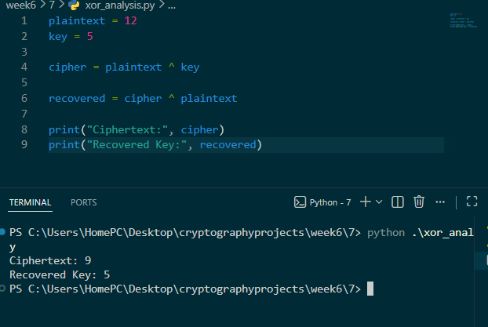

Figure 2: Differential cryptanalysis simulation comparing two similar plaintext inputs.

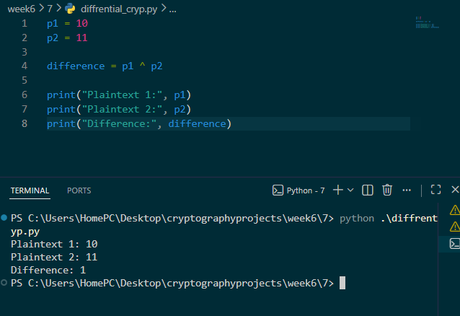

Figure 3: Frequency analysis output showing character distribution within encrypted data.

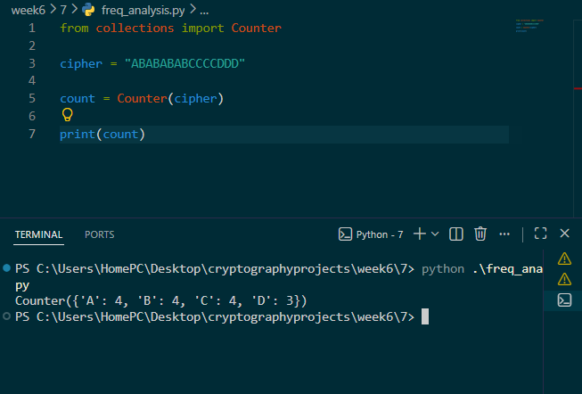

Figure 4: Avalanche effect experiment demonstrating output variation after changing one plaintext character.
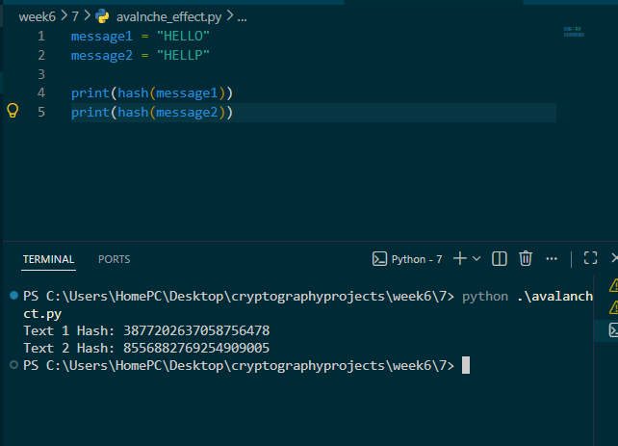
Figure 5: Security evaluation results illustrating AES resistance against algebraic, differential, and linear cryptanalysis techniques.
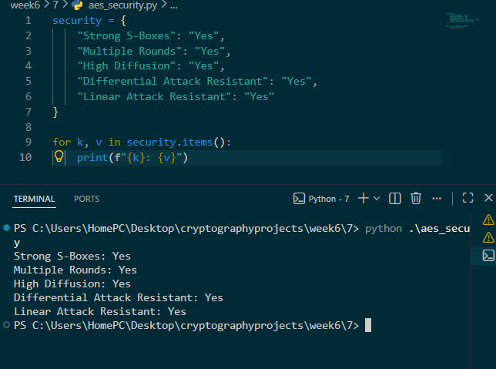
Weekly Reflection
This week's practical introduced cryptanalysis techniques used to evaluate block cipher security. Through XOR analysis, differential testing, frequency analysis, and avalanche effect experiments, I gained practical experience in identifying cipher weaknesses and understanding why AES remains resistant to modern cryptanalytic attacks.
Skills and Competencies Acquired
• Cryptanalysis techniques
• XOR and differential analysis
• Frequency and statistical analysis
• AES security evaluation
• Security testing using Python

